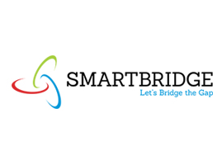



**Summer Project Report**

**A CASE STUDY ON FRUIT DETECTION**

**Submitted By, Supervisor:**

N Tharunsai Vidyasagar

Narlapally Anil Kunduru Anil Kumar Reddy

CH Vigneshwar Reddy

CH Sainaag

(Signature of Supervisor)

**CERTIFICATE**

This is to certify that the Dissertation entitled “FRUIT DETECTION WITH AI TECHNOLOGY” is a bonafide work done and submitted by the N Tharunsai Vidyasagar,NARLAPALLY Anil, CH Vigneshwar Reddy, and CH Sai Naag in the Smart Bridge Summer Internship programme Collaborated with IBM, has successfully completed during the time period from 27th May 2019 to 15th June 2019 under the guidance of Mr. Kunduru Anil Kumar Reddy in the department of Information Technology

The Results presented in this dissertation have been verified and are found to be satisfactorily.

(Signature)

**ACKNOWLEDGEMENT**

It is our privilege and pleasure to express our profound sense of Respect, Gratitude, and to our Guide Mr.Anil Kunduru who has given us the great opportunity to work on this project. He has been a great source of inspiration and her timely support and guidance has helped in the successful completion of the same. we also thank Mr.Charan Reddy whose creative suggestions and timely interventions helped me a lot during the process. we express our sincere thanks to Mr. Anil Kunduru who guided us throughout the project.

I thank Smart Bridge Summer Internship Programme Organizers.

NALLA THARUNSAI VIDYASAGAR

CHERKUPALLY VIGNESHWR REDDY

NARLAPALLY ANIL CHIRIPURAPU SAI NAAG

**CONTENTS**

**Description Page No**

1. Introduction 1
2. Literature Review 2
3. Data Collection 3
4. Methodology 4-6
5. Findings and suggestions 7-8
6. Conclusion 9
7. Bibliography and Reference 10

**INTRODUCTION**

Python along with packages like NumPy, scikit-learn, IPython Notebook and matplotlib from the basis to start your AI project.

NumPy is used as a container for generic data comprising of an N-dimensional array object, tools for integrating C/C++ code, Fourier transform, random number capabilities, and other functions.

Another useful library is pandas, an open source library that provides users with easy-to-use data structures and analytic tools for Python.

Matplotlib is another service which is a 2D plotting library creating publication quality figures. You can use matplotlib to up to 6 graphical users interface toolkits, web application servers, and Python scripts.

Your next step will be to explore k-means clustering and also gather knowledge about decision trees, continuous numeric prediction, logistic regression, etc.

Some of the most commonly used Python AI libraries are AIMA, pyDatalog, SimpleAI, EasyAi, etc. There are also Python libraries for machine learning like PyBrain, MDP, scikit, PyML.

**1.1 Objectives of Research**

In this project we will demonstrate how to build a model predicting fruit and Nutritious values in Python using the following steps

* data exploration
* building training/validation/test samples
* model selection
* model evaluation

**1.2 Problem Statement**

To build a model such that it should predict the name of the image and the properties of that image which is useful for everyone.The problem Statement of Our project is to predict the name of the fruit and determine the nutritious content of that fruit

**1.3 Industry Profile**

The user can use this model for predict the name of the fruit by capturing the image of that fruit through the application. Further, the user can also know more information of that fruit

1

**2. LITERATURE REVIEW**

­­­­­

* Texture, Shape and Size are the important parameters for fruit identification
* The Colour recognization is very important in Identifying Fruit Name

2

**3. DATA COLLECTION**

**Context**

A high-quality, dataset of images containing fruits were collected from the kaggle.com.

The following fruits are included for the present model to demonstrate:

* Apple Red
* Banana
* Orange
* Strawberry

**Dataset properties**

* Training set size: **654** images.
* Validation set size: **654** images.
* Number of classes: **4** (fruits).
* Image size: **100x100** pixels.
* File format: Image (**.jpg**)

**Content**

The dataset has been chosen after referring the various datasets in kaggle.com which is suitable forour model .There are all fixed sized pixel images in the Dataset

3

**4. METHODOLOGY**

**Importing packages:**

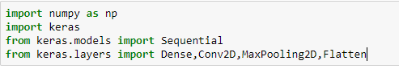

**Reading an Image From Folder**

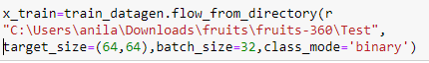

**CNN**



**Flatten**



**Activation Function**



**Compilation**



**Model Fitting**

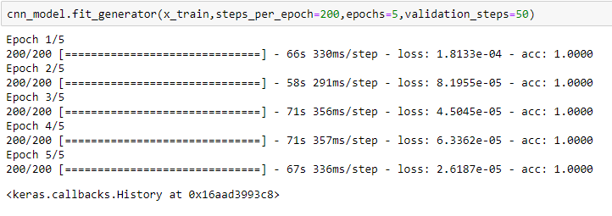

4

**Saving**



**Loading Model**



**Pre-processing**

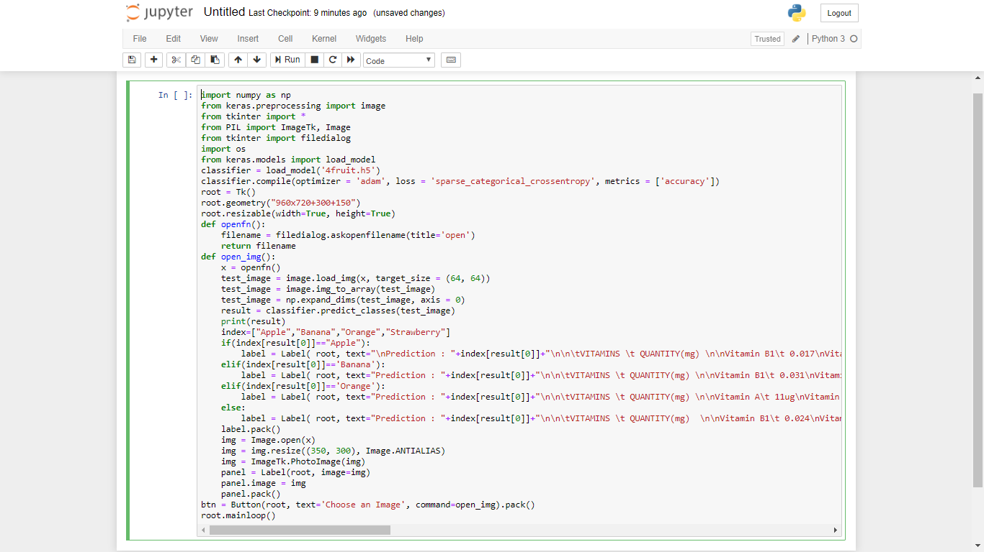

5

**OUTPUT**

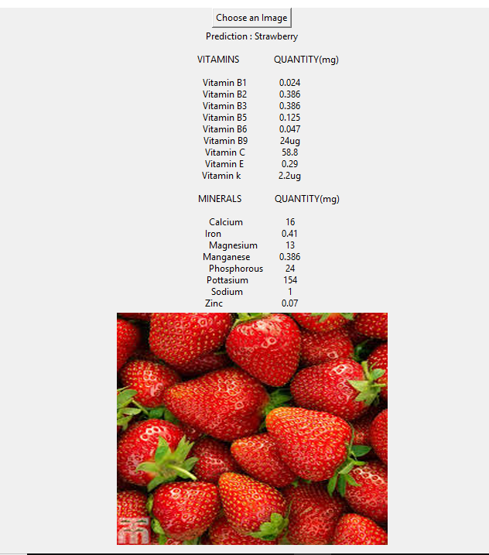

6

**5. FINDINGS AND SUGGESTIONS**

The best model for predicting the various kinds of fruits with the most accuracy and least loss can be found in this model. The model was able to catch almost 98% accuracy in predicting the various fruits and with the least loss of approximately 5%.

**Fruit Recognization Process**

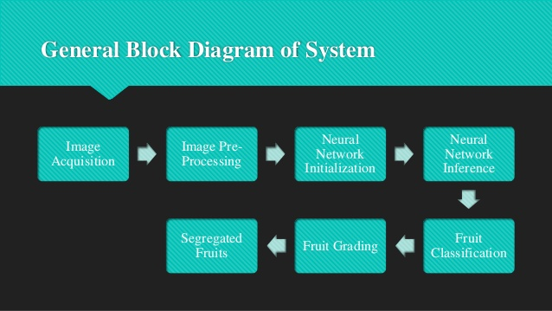

7

**Pre-Processing**

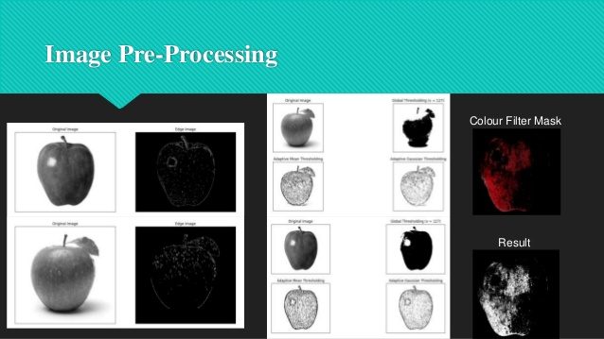

8

**6. CONCLUSION**

We have choose this model to provide a perfect user case development which is required for the user. The user can be aware of various kinds of fruits and we can retain the Nutritious Information of that fruit. This model is helpful for the Hospitals to know the nutritious values of that fruit and provide the patients according to these values. This model was accomplished with the intention to know all the uses of fruits to be available for everyone in an effective way.

9

1. **BIBILIOGRAPHY**

* Install Anaconda Navigator

<https://www.anaconda.com/>

* Install Keras

!pip install keras in Jupyter Notebook

Conda install keras in Anaconda Prompt

* Learn Python Basics

<https://docs.python.org/3/>

10